# Report for Isaiah Lopez (2024-10-01 to 2024-10-31)

Average Bat Speed: 45.96

Average Rotational Acceleration: 8.66

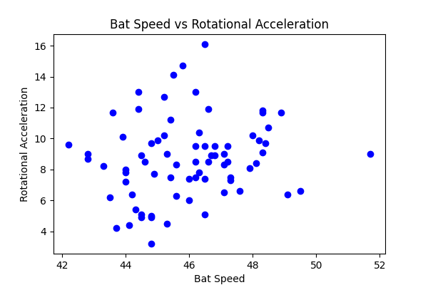

## Comments

Add comments here...